“Four Decades of Innovation, Inspiration and Impact”
Keynote presentation by Dr. Michael Main at the 40th anniversary International Bubble Conference in Chicago (October 1, 2026)

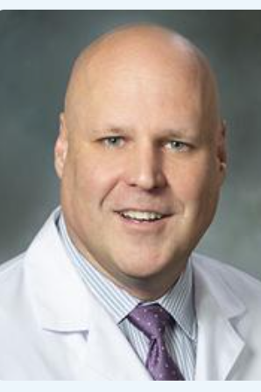 | Dr. Michael Main is a board member and co-founder of the International Contrast Ultrasound Society, professor of medicine at the University of Missouri-Kansas City, President of Saint Luke's Physician Group, and Chief Clinical Officer for BJC Health System (West Region). A distinguished cardiologist, Dr. Main is an internationally recognized authority in contrast-enhanced ultrasound (CEUS). He has led landmark investigations into the safety of ultrasound contrast agents, producing much of the evidence that established their favorable safety profile and informed regulatory and clinical practice changes. His leadership, research, and advocacy have been instrumental in advancing the use of CEUS for millions of patients worldwide.
Overview
Dr. Main's keynote presentation traced the 40-year evolution of contrast-enhanced ultrasound (CEUS), highlighting the scientific breakthroughs, regulatory challenges, multidisciplinary collaborations, and leadership that transformed microbubble contrast imaging from an experimental concept in the 1980s into a globally recognized diagnostic and therapeutic tool.

1. Origins: The Early Years of Contrast Echocardiography
Dr. Main recalled the cardiovascular landscape of the 1980s, a period marked by major advances in treating acute myocardial infarction. Against that backdrop, pioneers in contrast echocardiography explored whether microbubbles could be used to visualize myocardial perfusion and answer critical clinical questions:
- What properties should an ideal myocardial perfusion agent possess?
- Could contrast agents survive transpulmonary passage?
- Could ultrasound identify the myocardium at risk during acute infarction?
- Could infarct size be measured noninvasively?
Dr. Main showed images from the earliest Bubble Conferences and highlighted landmark studies from the early 1980s demonstrating visualization of myocardial perfusion abnormalities with contrast-enhanced echocardiography.

2. Breakthroughs
First-generation contrast agents and fundamental imaging soon evolved and let to modern microbubble agents and harmonic imaging. Key advances included:
- Development of second-generation transpulmonary contrast agents.
- Introduction of harmonic imaging techniques.
- Dramatically improved visualization of myocardial perfusion.
- Enhanced endocardial border definition and cardiac chamber opacification.
Mounting evidence showed that contrast-enhanced echocardiography improved agreement with cardiac MRI measurements, reinforcing the technique's clinical validity and reliability.

3. Expanding Clinical Applications
CEUS continued to evolved beyond simple cardiac chamber enhancement and became a tool for assessing:
- Myocardial perfusion.
- Area at risk during acute ischemia.
- Infarct size following myocardial infarction.
- Stress imaging and detection of coronary artery disease.
Meanwhile, pivotal Phase III studies compared myocardial contrast echocardiography with established nuclear imaging techniques such as SPECT, illustrating both the promise and challenges of bringing these innovations into routine clinical practice.

4. The FDA Boxed Warning Crisis
One of the most important historical moments occurred in October 2007 with the U.S. Food and Drug Administration (FDA) imposed boxed warnings on Definity and Optison, which at the time were the only two commercially available ultrasound contrast agents.
The FDA actions included:
- Boxed warnings concerning serious cardiopulmonary reactions.
- Contraindications involving unstable cardiovascular and pulmonary conditions.
- A mandatory 30-minute post-administration monitoring period.
Dr. Main described the reaction from the contrast ultrasound community, which was concerned that the new “black box” did not reflect the established safety and benefits of the agents. CEUS experts formally requested FDA reconsideration and advisory review.
Subsequent research, including large meta-analyses, demonstrated no significant increase in adverse cardiovascular events associated with ultrasound contrast agents, helping to support eventual regulatory modifications.
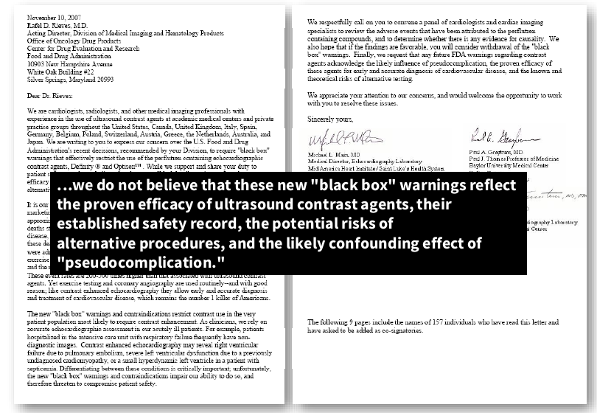

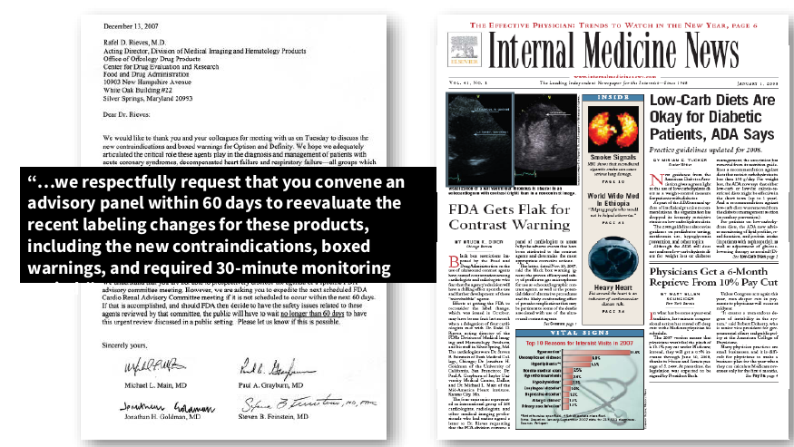

5. A Turning Point: From Cardiology to Multidisciplinary Ultrasound
The new “black box” triggered broader awareness of CEUS uses for a broad range of indications extending far beyond cardiology, and the 2008 Bubble Conference welcomed CEUS experts from: Radiology
- Vascular imaging
- Gastroenterology
- Pediatrics
- Oncology
- Abdominal imaging and other specialties
In opening the 2008 meeting, Conference Director Dr. Steven Feinstein emphasized the need for greater cross-specialty collaboration and launched the International Contrast Ultrasound Society as a new voice for the broader multi-disciplinary global CEUS field.

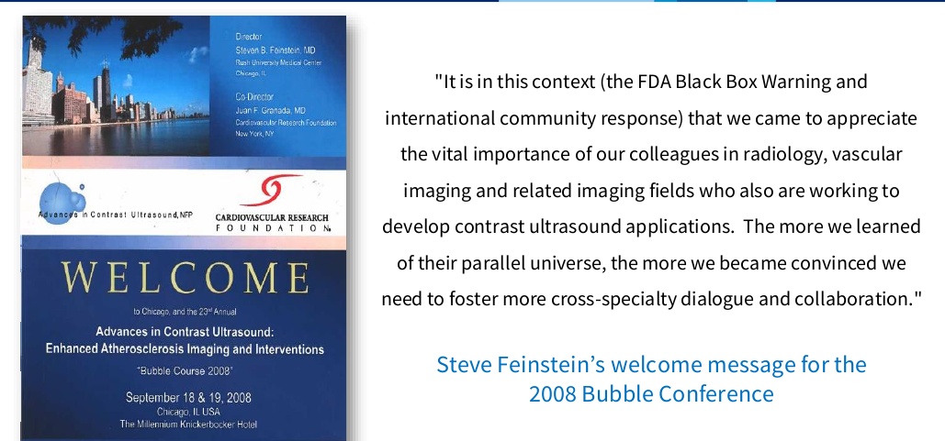

6. The Four Enduring Themes of the Bubble Conference
Dr. Main identified four principles that have sustained the Bubble Conference and the CEUS community over four decades:
Innovation and Translation
Pioneering safe, noninvasive imaging and therapeutic applications and translating scientific discoveries into clinical practice.
Cross-Specialty Collaboration
Bringing together physicians, scientists, engineers, sonographers, nurses, and industry leaders from multiple specialties to pursue common goals.
Global Leadership and Advocacy
Advancing education, standards, access, and acceptance of CEUS worldwide.
Community, Mentorship, and Lifelong Relationships
Developing future leaders while fostering enduring professional and personal relationships within the ultrasound community.
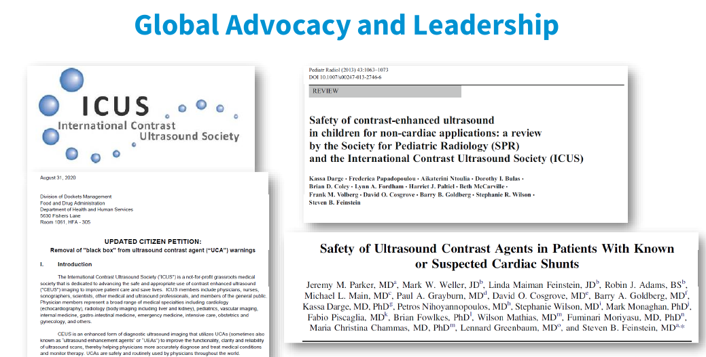

7. Tribute to Dr. Steve Feinstein
The keynote culminated in a heartfelt tribute to Steve Feinstein, recognizing his central role in building the Bubble Conference and advancing CEUS worldwide. Dr. Main emphasized that millions of patients have benefited from four decades of leadership, mentorship, advocacy, and friendship.

Key Takeaway
Dr. Main's presentation was both a history lesson and a celebration. It showed how a small group of innovators gathered in Chicago four decades ago with a handful of scientific questions and helped create a global field. The keynote underscored that the success of CEUS resulted not only from technological innovation but also from collaboration across specialties, persistent advocacy in the face of regulatory challenges, strong mentorship, and visionary leadership, particularly that of Steve Feinstein.

